Project Goals
Improve the resulting product in 3 direction:
- Packaging: make the closed lamp more compact and suitable for transportation
- Energy: use a more powerful power bank (from 5Ah to 10 Ah)
- Flexibility: add a few fixture to attach cameras or phones.
- Add Self Locking Nuts for better control of frictions along hinges

Dimensions
Base Size:
Closed Height
Total Height

Images
Below a set of images of the assembled lamp

Components

Power bank
This is the power bank I have incorporated in the project.
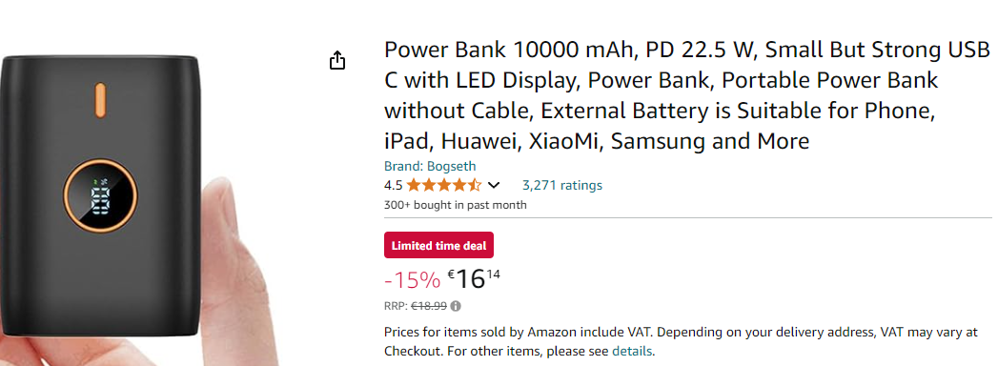
Amazon Germany: https://amzn.eu/d/j4mhf3Z
Amazon Italy: https://amzn.eu/d/agR1Bto
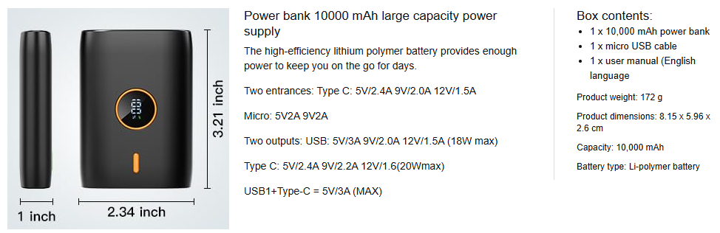

Why I choose it:
→ Mainly because it has a USB A on one side and USB-C / Micro USB for charging in the opposite side.

Switching regulator
This small circuit trigger the USB port of the Power Bank and then convert the USB Bus voltage up to 28 VDC. For this application I have adjusted the out to 24VDC
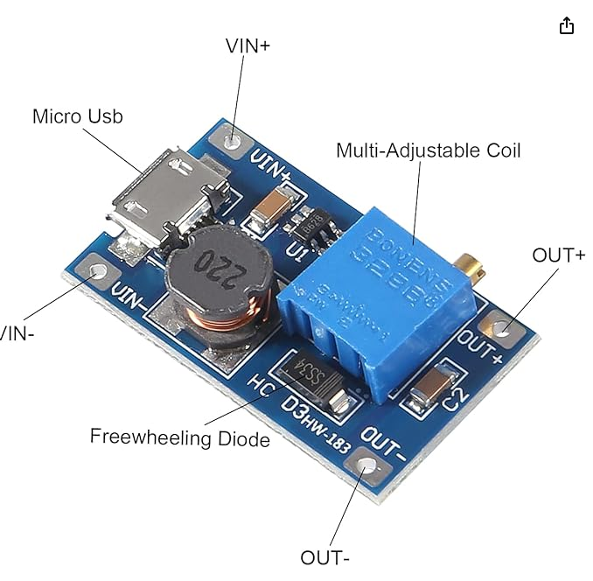

LED Strip
I use 24 VDC COB Led Strip

Nuts and Bolts
The project requires also
6 x M3x16 mm Bolts
7 x M6x30 mm Bolts
14 6 mm washers
7 Self Locking Nuts

Elements

Base

Battery Back

Cover

Switch
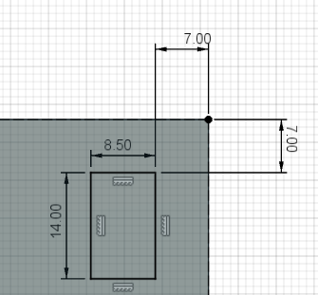

Base Joint

Long Joint

Small Joint

Double Axis Beam

Beam
20 x 16 mm
Holes: 6.20 mm
Lenght: 170 mm

Lamp

Base Joint

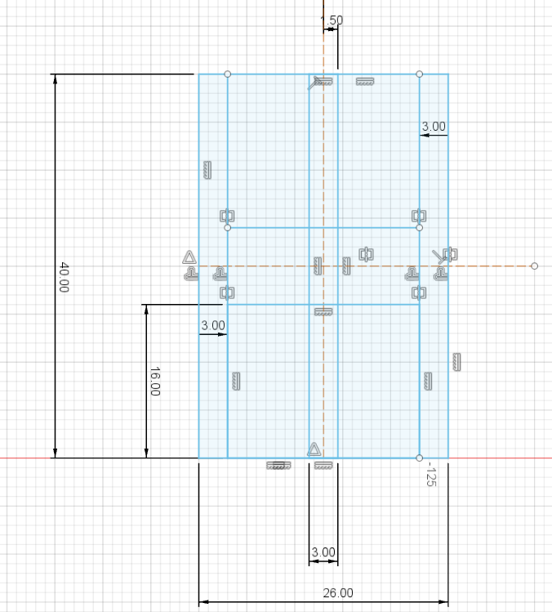 \

Base Mounting Screws
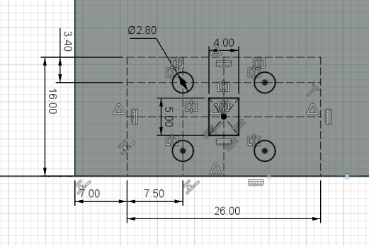

Battery closure
